Character Analysis
- Looking at your sociogram of your play:
https://www.cliffsnotes.com/literature/h/hamlet/character-map | https://www.cliffsnotes.com/literature/m/macbeth/character-map
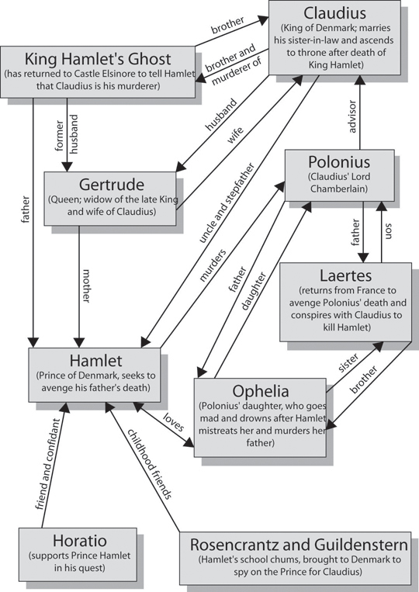 | 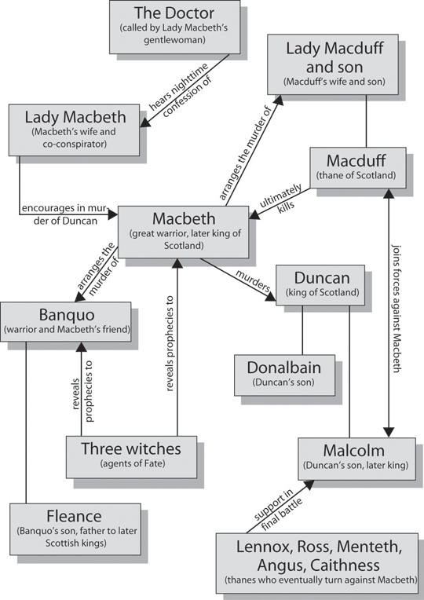

- Select two characters to analyse.
- The two characters I will analyse are ________________________________ and __________________________.
- Create a “____________________ only play” [insert your character’s name in the blank]

Use the digital full text to search your character’s appearances in the play [ctrl f]. Copy and paste into the table below. Add your comments in the right hand column.

 | Act #  Sc # | Quote  (including Act#Scene#) | What this quote tells us about this character
Beginning
Middle
End

- Looking at the plot from your character’s perspective.
Section | Key Questions | Act 1 | Act 2 | Act 3 | Act 4 | Act 5
A | What is happening for my character in particular?  List the events for him/her.
B | How does my character feel about these events?
C | Why does my character feel this way?
D | Identify the pivotal moment for my character (where everything changes from that moment forward.
E | What is my character feeling at this pivotal point?  Select feeling words from the list of feeling words at the end of this document.  (We are aiming for the most precise feeling words possible not just happy/sad) | Name the emotion.  My character feels _______________, _______________, and _______________, | Name the characters it involves.  _____________  My character feels this way because ________________________________________________________________________________________________________________________
F | Name the emotion and actions that your character has to get to at the end of your narrative insert (in order to come back into the logical sequence of the play). | My character has to feel____________  by the time he/she completes the action of _____________
G | Map the plot of your narrative | My character is _______________ | At this point in the play he/she is located at ____________________________________________________________________________________ | His/her main dilemma to resolve is _______________________________________________________________________________________________________________________________
H | Tension in my narrative | Beginning of my narrative  At first my character is feeling ____________________ and thinking_____________________________________________ | Middle of my narrative  Fill this box in after you answer the box to your right.>  The steps my character takes to get to the climax of feelings and thoughts are:  1  2  3 | Climax of my narrative  At the climax he/she is feeling ________________ and thinking ____________________________________________________ | Denouement of my narrative  After he/she has reached the climax, I will bring her/him back to the original script by explaining _____________ [* check this against your answer in section F]
I | Row H forms the plot for your narrative. (Yay!)
J | Before you start writing create a Language Bank.  Online activity:  Go to the link and click on the “Match” option  https://quizlet.com/63986374/figurative-language-quotes-in-macbeth-flash-cards/ | Go through the quotes you collected earlier and identify:> | Three symbols I could include in my narrative.  1.  2.  3. | Five uses of figurative language (including simile, metaphor, personification, hyperbole, alliteration, oxymoron, pun)  1.  2.  3.  4.  5. | If you want a quick recap of these in Shakespeare:  http://www.buzzle.com/articles/examples-of-figurative-language-used-in-hamlet.html | If you want to check the definition of particular figurative language devices:  http://www.buzzle.com/articles/types-of-figurative-language.html

List of feeling words copied from https://www.vocabulary.com/lists/535865

abandoned
forsaken by owner or inhabitants
Adopted children must face issues of abandonment as they grow older.
accepted
generally approved or compelling recognition
He has been a wonderful guy from the start and has alwaysaccepted my oldest, even though he is not his biological father.
— Washington Post
aggressive
characteristic of an enemy or one eager to fight
But Bowser could appoint new and aggressive leaders in other city agencies, where Gray’s appointees have tended to be more cautious.
— Washington Post
alienated
socially disoriented
The more vigilant Allen was, the more resentful andalienated Nicholas became, and the worse things got.
— Class Matters
amazed
filled with the emotional impact of overwhelming surprise
White was amazed when around 500 people showed up.
— Washington Times (Nov 9, 2014)
amused
pleasantly occupied
"I can tell you, he's keeping his doctors amused."
— US News (Nov 6, 2014)
anxious
causing or fraught with or showing anxiety
When rumors have circulated that officers were about to clear the site, Chan has sought to calm anxious protesters.
— Los Angeles Times (Nov 12, 2014)
apathetic
showing little or no emotion or animation
“And some people are able to inspire otherwise apatheticyoung people to vote.”
— Forbes (Oct 21, 2014)
ashamed
feeling guilt or embarrassment or remorse
Then, ashamed and embarrassed, he disappeared under a duvet and grieved.
— BBC (Nov 4, 2014)
astonished
filled with the emotional impact of overwhelming surprise
"Oh my God," he sputters, clearly astonished by the claim.
— BBC (Oct 18, 2014)
aversion
a feeling of intense dislike
One awareness patient, formerly a jazz aficionado, developed a bizarre aversion to the style after an awareness experience.
— Scientific American (Nov 11, 2014)
avoidance
deliberately avoiding
A small percentage use it for avoidance, to create a distraction, and an even smaller percentage use it to get attention.
— New York Times (Oct 30, 2014)
awed
inspired by a feeling of fearful wonderment or reverence
Who can forget being awed by the choreographed treadmill dance from “Here We Go Again”?
— Salon (Oct 27, 2014)
awful
exceptionally bad or displeasing
Well, it's ugly, it's awful, but at least it's official.
— Los Angeles Times (Nov 11, 2014)
bored
tired of the world
But she is too bored and depressed to sleep.
— New York Times (Nov 11, 2014)
confident
having or marked by assurance
And Pierce, confident as ever, will not hesitate to shoot.
— Washington Post
confused
unable to think with clarity or act intelligently
Veterans service organizations had braced for a flood of calls from confused veterans, but said so far they’ve not heard any complaints.
— Washington Times (Nov 11, 2014)
courageous
able to face and deal with danger or fear without flinching
"To share in this way is courageous, powerful and generous," Dunham tweeted at the time, adding a link to Dylan Farrow's letter.
— Seattle Times (Nov 4, 2014)
critical
marked by a tendency to find and call attention to flaws
Try not to be too critical when assessing students' first drafts, but do focus on key places where they can improve.
depressed
filled with melancholy and despondency
Hours of rehabilitation left him feeling depressed at times.
— Los Angeles Times (Nov 11, 2014)
despair
a state in which all hope is lost or absent
At the end, in despair, Katerina drowns herself in a lake, dragging her rival with her.
— New York Times (Nov 11, 2014)
detestable
offensive to the mind
Instead of making him more likable, it made him moredetestable and he ended up becoming passive-aggressive.
— Salon (Oct 19, 2014)
devastate
overwhelm or overpower
In the aftermath of the quake, ordinary Italians weredevastated and outraged.
— The Verge (Nov 11, 2014)
disappointed
sadly unsuccessful
One mother, Koh Young-hee, said she was deeplydisappointed and furious because she had hoped that all of the defendants would be sentenced to death.
— Washington Post
disapproving
expressing or manifesting disapproval
Orton was sitting at a table with friends beside a "rather stuffy American tourist and his disapproving wife."
— BBC (Oct 11, 2014)
disillusioned
freed from false ideas
People were scared, disillusioned and confused, so they didn’t vote.
— Salon (Nov 10, 2014)
dismayed
struck with fear, dread, or consternation
One side was euphoric, the other dismayed, but both foes and supporters of same-sex marriage swiftly turned their attention to the U.S.
— Washington Times (Nov 7, 2014)
disrespectful
exhibiting lack of regard; rude and discourteous
"It appears some disrespectful cowards spray painted their tagging crew and tagger names over the memorial," the police department stated on its Facebook page.
— Los Angeles Times (Nov 11, 2014)
distant
remote in manner
Her parents, though, were distant, and the young Jean soon developed the strong independent streak which has characterised her life.
— BBC (Nov 10, 2014)
eager
having or showing keen interest or intense desire
Democratic-primary voters are always eager to see a fresh potential candidate.
— The New Yorker (Nov 10, 2014)
ecstatic
feeling great rapture or delight
"I was just so ecstatic to get the ring back."
— Chicago Tribune (Nov 6, 2014)
embarrassed
feeling or caused to feel uneasy and self-conscious
Together, they embrace then pull apart as if embarrassedby the physical closeness.
— Seattle Times (Nov 10, 2014)
empty
void of emotion
Instead I felt empty, and inside I wanted to cry.
— BBC (Nov 11, 2014)
energetic
possessing or displaying forceful exertion
Niall had been a goofy, energetic, creative kid who wasn’t quite sure what he wanted to do with his life.
— Washington Post
enraged
marked by extreme anger
When he returned home, he searched his wife’s cell phone and became enraged when he found a picture of another man, prosecutors said.
— Reuters (Nov 7, 2014)
excited
in an aroused state
"Musically, visually, the image, the performance, everything aligned. I was very excited."
— Los Angeles Times (Nov 12, 2014)
frightened
made afraid
“If someone talks about using force, I am frightened,” she said.
— New York Times (Nov 9, 2014)
frustrated
disappointingly unsuccessful
"But it still make me sad that I can’t speak well. I call my interpreter when I get frustrated."
— Reuters (Nov 12, 2014)
fulfilled
completed to perfection
Cut to a shot of a walker shambling ever forward, presumably happy and fulfilled by his life’s “ambition” to eat another brain.
— Time (Nov 9, 2014)
furious
marked by extreme anger
White House officials were furious, calling Krone's behavior "unprofessional."
— Seattle Times (Nov 10, 2014)
guilty
showing a sense of wrongness
Bonus points for having Unser actually feel guilty about taking a life.
— Los Angeles Times (Nov 12, 2014)
hateful
evoking or deserving hatred
Most people have been supportive, she said, but others have been hateful.
— Los Angeles Times (Nov 9, 2014)
hesitant
unable to act or decide quickly or firmly
He is hesitant around me, kind of respectfully shy.
— The Help
hopeful
having or manifesting optimism
His critique of Reaganism, published in 1986, missed what others plainly saw, that a genuinely hopeful spirit was animating the American right.
— New York Times (Nov 9, 2014)
hostile
characterized by enmity or ill will
They continued to back Mr. Dunkle, saying an independent investigation had found he had not created a hostile work environment, Bishop Sisk said.
— New York Times (Nov 7, 2014)
humiliated
subdued or brought low in condition or status
I felt humiliated in front of my colleagues and unmasked as a weak person not competent to manage difficult patients.
— Slate (Nov 9, 2014)
hurt
psychological suffering
“It hurts me and it pains me. Paul is with him, but I sometimes feel like I’m failing as a mother.”
— New York Times (Nov 12, 2014)
ignored
disregarded
Have you ever felt ignored for no reason at all?
important
of great significance or value
Giving children a time to present their work makes them feelimportant, which leads to their taking their work more seriously.
inadequate
not sufficient to meet a need
Watching your children founder in school can leave a parent feeling hopeless and inadequate.
indifferent
marked by a lack of interest
A few staffers, though, seemed either indifferent or downright surly.
— Forbes (Nov 7, 2014)
inferior
of low quality
We love watching the pros, but let's be honest, it can make us feel a bit inferior when it comes to our golf games.
— Golf Digest (Oct 16, 2013)
infuriated
marked by extreme anger
The result was an act of parliament that, in attempting to satisfy everyone, infuriated millions.
— BBC (Nov 6, 2014)
inquisitive
showing curiosity
Her older sister, Boedges added, “is an inquisitive girl, very talkative.”
— Washington Post
insecure
lacking self-confidence or assurance
I was so insecure, and I hated myself.
— Time (Nov 1, 2014)
insignificant
of little importance or influence or power; of minor status
“Hell, a kid’s already scared of being small andinsignificant,” he once said.
— The New Yorker (Nov 5, 2014)
inspired
of surpassing excellence
Are you feeling inspired and ready to put your new-found, seemingly easy strategies into action starting tomorrow?
— Forbes (Nov 12, 2014)
interested
showing curiosity or fascination or concern
She learned Braille “because I’m interested in tactile things. I’m interested in hair as a language. So why not go to a tactile language?”
— Washington Times (Nov 9, 2014)
intimate
marked by close acquaintance, association, or familiarity
The couple grew so intimate that the woman promised she would move to New York in six months.
— New York Times (Nov 7, 2014)
irritated
aroused to impatience or anger
But he spoke like a frustrated political veteran, as if decades of merely watching the news had left him irritated and saddened.
— The New Yorker (Nov 4, 2014)
isolated
being or feeling set or kept apart from others
"Growing up, I was isolated from this issue, rarely talked about it," Stonebraker said.
— Reuters (Nov 11, 2014)
jealous
suspicious or fearful of being displaced by a rival
"I think it was really hard. I think he was a little jealous of the video guy at first," Gomez joked.
— Los Angeles Times (Nov 6, 2014)
joyful
full of or producing great happiness
Investors squeezed in a joyful one-hour lunch break before the afternoon panels.
— Forbes (Nov 8, 2014)
judgmental
depending on assessing a person or situation or event
Those who are asleep at the switch, or judgmental, get hurt.
— New York Times (Nov 10, 2014)
liberated
free from traditional social restraints
It was as if the reduced expectations had liberated her.
— Washington Post
loathing
hate coupled with disgust
The man they are seeking is described as a survivalist and an excellent shot, with a loathing for law-enforcement officials.
— New York Times (Sep 21, 2014)
lonely
marked by sadness from being by yourself
Company exhausted him, even though he grew lonely in its absence.
— Slate (Nov 5, 2014)
loving
feeling or showing love and affection
"He was so patient. He wasn't a complainer. He was soloving, despite all the stuff that he went through," his wife said.
— US News (Nov 11, 2014)
mad
roused to anger
“Because either way you voted on that, you’re making somebody mad. And the financial sector was furious.”
— The New Yorker (Nov 10, 2014)
open
straightforward and direct without reserve or secretiveness
What’s more, other governments seem open to following the example from Down Under.
— Time (Nov 12, 2014)
optimistic
expecting the best
She said the talks were going well and she felt optimisticthat progress could be made.
— BBC (Nov 12, 2014)
overwhelm
overcome, as with emotions or perceptual stimuli
She was a little overwhelmed with being the adored focus of such power, as he rose and fell.
— The Guardian (Nov 12, 2014)
peaceful
not disturbed by strife or turmoil or war
In 2001, my husband and I ditched the dot-com rat race of Silicon Valley for a more peaceful life in the mountains of Lake Tahoe.
— New York Times (Nov 10, 2014)
perplexed
full of difficulty or confusion or bewilderment
The bankers who arrange the loan deals say that they areperplexed.
— New York Times (Nov 4, 2014)
playful
full of fun and high spirits
He says the fourth “Toy Story” installment will “open a new chapter” in the lives of Woody, Buzz and their playful pals.
— Washington Times (Nov 7, 2014)
powerful
having great force or effect
The first option is benevolent, but the second is powerful.
— Forbes (Nov 12, 2014)
powerless
lacking power
If anything goes wrong then, scientists will be powerless to do anything but watch.
— Seattle Times (Nov 11, 2014)
proud
feeling self-respect, self-esteem, or self-importance
“He’s very stubborn, a little fighter. And that’s why I’m proudof him,” his father told the TV station.
— Los Angeles Times (Nov 12, 2014)
provocative
serving or tending to excite or stimulate
The teenagers did not appear to be engaged in violent orprovocative behavior at the time they were shot.
— New York Times (Nov 12, 2014)
rejected
rebuffed (by a lover) without warning
The break up with his best friend left him feeling lonely,rejected, and generally out of sorts.
remorseful
feeling or expressing pain or sorrow for sins or offenses
In a statement, Chow said the running back was “contrite, embarrassed and remorseful.”
— Washington Times (Oct 15, 2014)
repugnant
offensive to the mind
These incidents now strike us as repugnant discrimination.
— Slate (Nov 7, 2014)
resentful
full of or marked by indignant ill will
This is how we, the electorate, are being described: sour, dyspeptic, demoralized, disgusted, rebellious, frustrated,resentful, angry.
— Seattle Times (Nov 7, 2014)
respected
receiving deferential regard
“It makes people feel appreciated, valued and respected.”
— US News (Nov 11, 2014)
ridicule
the act of deriding or treating with contempt
Have football's routinely ridiculed executives actually changed something for the better?
— BBC (Nov 12, 2014)
sarcastic
expressing or expressive of ridicule that wounds
“I was thrilled we shot more free throws as a team than James Harden,” a sarcastic Sixers coach Brett Brown said.
— Seattle Times (Nov 4, 2014)
scared
made afraid
"I'm scared right now," she said as she watched smoke from the burning house.
— US News (Nov 11, 2014)
sensitive
responsive to physical stimuli
The child was sensitive, perceiving even the slightest teasing as an aggressive attack.
shocked
struck with fear, dread, or surprise
The photo of a wide-eyed, shocked Loren glancing over at Mansfield captures a classic Hollywood moment.
— Los Angeles Times (Nov 12, 2014)
skeptical
marked by or given to doubt
Faced with skeptical — or sexist — editors and colleagues, the women found that work sometimes came at the price of their personal lives.
— New York Times (Nov 12, 2014)
startled
excited by sudden surprise or alarm and making a quick involuntary movement
submissive
inclined or willing to give in to orders or wishes of others
Finally, a textbook that teaches women the manly pursuit of science in terms that our feeble, submissive lady brains will understand.
— Salon (Oct 14, 2014)
suspicious
openly distrustful and unwilling to confide
The survey suggested that most customers remainedsuspicious of how companies used their data.
— BBC (Nov 12, 2014)
terrified
thrown into a state of intense fear or desperation
"She knew she was going to be murdered. She wasterrified".
— BBC (Nov 12, 2014)
threatened
likely in the near future to become endangered
"I was disgusted that my voice was ignored, but they feltthreatened after being called by a politician."
— BBC (Nov 12, 2014)
victimized
of persons; taken advantage of
Any girl suspected of being attracted to girls was gossiped about, victimized, and shunned.
— Middlesex: A Novel
vulnerable
capable of being wounded or hurt
"She is so funny and vulnerable," he said.
— Los Angeles Times (Nov 12, 2014)
withdrawn
tending to reserve or introspection
Executive coach Maureen Moriarty believes that those who fail to communicate their feelings at work are often perceived as aloof, cold, withdrawn or untrustworthy.
— US News (Nov 11, 2014)
worried
afflicted with or marked by anxious uneasiness or trouble
According to the survey, 80% of Americans are worried about the government’s monitoring of phone and Internet communications.
— Wall Street Journal (Nov 12, 2014)
worthless
lacking in usefulness or value
“I was just tired of it. I was letting my family down; I was feeling worthless.”
— US News (Nov 5, 2014)

